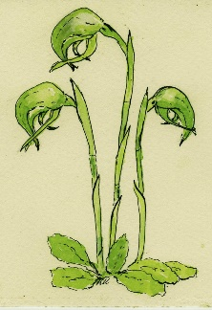
CASTLEMAINE FIELD NATURALISTS CLUB Inc. #A0003010B
P.O. Box 324, Castlemaine, Victoria 3450
www.castlemainefieldnaturalists.org.au
castlemainefnc@hotmail.com
APPLICATION FOR MEMBERSHIP
Personal details
Name(s):

Residential address:
Postal address:
Phone:

Email:

The club’s monthly newsletter “Castlemaine Naturalist” is distributed by email, but printed copies can be arranged on request (see email and mailing address above).
New members will be added to our email subscribers list for activity announcements and changes. You may unsubscribe from this at any time.
Do you wish to receive newsletters from other clubs (3) by email? | Y/N
I/We agree to accept and support the Purposes and Rules of the Club (these are available from the Secretary).
Signature(s) of Applicant(s)……………………………………………..…………………… Date / /
Applications for membership should be accompanied by payment for the annual membership fee
(there is no joining fee).
Single membership |  | $35 |  | $ ............
Family membership |  | $50 |  | $ ............
Pensioner/Student/ Single Concession |  | $25 |  | $ ............
Pensioner/Student/ Family Concession |  | $30 |  | $ ............
Donation to support CFNC |  |  |  | $ ............
 |  | Total |  | $ ............
Payment method options (please enter X ): BANK TRANSFER [ ] CHEQUE [ ] CASH [ ]
- Make a bank transfer or deposit cash at a bank (Castlemaine Field Naturalists Club BSB 633 000 A/c No. 110396256) including your name as reference.
- Make cheque out to Castlemaine Field Naturalists Club.
Please return this form by email to castlemainefnc@hotmail.com or by post to the above address (with cheque if applicable).
Receipts are not normally sent, but can be on request: castlemainefnc@hotmail.com

Payment received on: / / Membership Form received: / /

