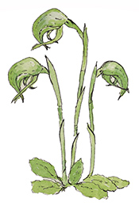
CASTLEMAINE FIELD NATURALISTS CLUB Inc. #A0003010B
P.O. Box 324, Castlemaine, Victoria 3450
www.castlemainefieldnaturalists.org.au
castlemainefnc@hotmail.com
MEMBERSHIP RENEWAL FORM 2025
Renewals are due by 1 April
Name(s):

Personal details (complete if details changed)
Residential address:
Postal address:
Phone:

Email:

The club’s monthly newsletter “Castlemaine Naturalist” is distributed by email, but printed copies can be arranged on request (see email and mailing address above).
Do you wish to receive newsletters from other clubs (3) by email? | Y/N

Membership renewals should be accompanied by payment for the annual membership fee.
Single membership $35 $............
Family membership $50 $............
Pensioner/Student/ Single Concession $25 $............
Pensioner/Student/ Family Concession $30 $.............
Donation to support CFNC $.............
Total $.............
Payment method options (please enter X ): BANK TRANSFER [ ] CHEQUE [ ] CASH [ ]
- Make a bank transfer or deposit cash at bank (Castlemaine Field Naturalists Club
BSB 633 000 A/c No. 110396256) including your name as reference.
- Make cheque out to Castlemaine Field Naturalists Club.
Please return this form by email to castlemainefnc@hotmail.com or by post to the above address (with cheque if applicable).
Receipts are not normally sent, but can be on request: castlemainefnc@hotmail.com

Payment received on: / / Membership Form received: / /

