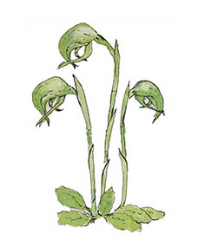
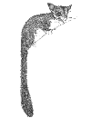
South East Australian Naturalists' Association Inc
A0044963D ABN 23 918 778 150

Spring Camp 2026
Friday 9th – Sunday 11th October 2026

Hosted by Castlemaine Field Naturalists Club Inc.
A0003010B ABN 91369536236

REGISTRATION FORM
To be returned to reach us by Friday 28th August
Names(s) | 1. |  |  | 2.
Address
Post Code |  | *Phone(s) | 1. |  | 2.
Email address(es): | 1.  2.
** Your Field Naturalists Club:
* Mobile phone preferred
** If NOT a member of a SEANA-affiliated Club, you need to join SEANA as a Lone Member (see below) to be eligible to attend this camp.

Payment details:
Registration | Number of  persons | Amount
Adult registration @ $45 per person
Child/student under 18 @ $30
SEANA Lone Membership if not a member of a FNC @ $10
Meals Friday evening meal @ $30 per person
Saturday evening meal @ $40 per person
RV site at Campbells Creek CC – $10 per vehicle per night
TOTAL

Please pay by Direct Bank Transfer (either online or in person at your bank):
Bank details: BSB: 633 000; A/c name: Castlemaine Field Naturalists Club SEANA
A/c no: 165725755. Include as reference your surname and initials.
Return this form to reach us by August 28th by email: seanacfnc@gmail.com or by post to Castlemaine Field Naturalists Club, PO Box 324, Castlemaine VIC 3450

PLEASE SEE OVER

TO HELP US WITH PLANNING:

If you have any dietary requirements, please note these:

Please indicate if you will be staying on for the Sunday night pub meal Y (no. of persons )/ N

RV and caravan facilities at Campbells Creek Community Centre: $10 per vehicle per night.
There are no powered sites, and no showers. Water and toilets are available, and some access to the kitchen facilities. There are RV waste dump facilities at the BIG4 Castlemaine Gardens Holiday Park, and at Bridge St, Harcourt, north of Castlemaine.

To assist us with planning for excursions, please indicate which of the following topics are of interest to you (tick all those of interest):

- Wildflowers
- Birds
- Insects and fauna
- Trees
- Geology of the Goldfields
- Impacts of gold mining on the Goldfields ecology
- Impacts of fire on native bushland of the Castlemaine region
- Landscape and habitat restoration
- Other:

Comments:

